All commands was easy quick to get information providing faster way to work. Home directory was not given permission to edit by user so I used sudo command to run touch command in home directory to create file.

Task 1

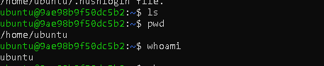

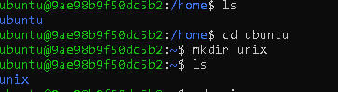

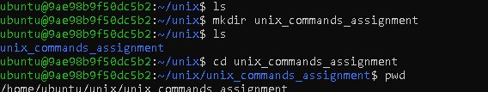

Task 2



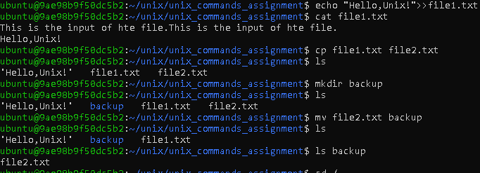

Task 3

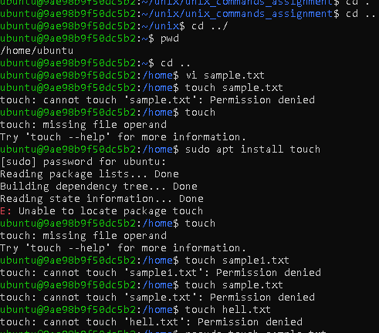





Task 4

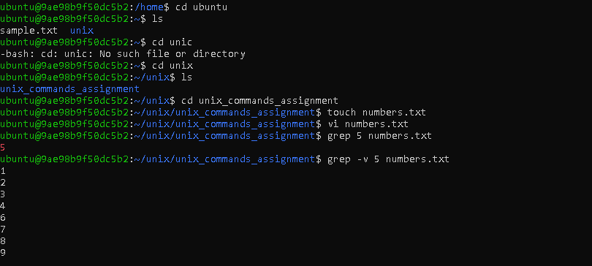

Task 5

